Sample Communication Examples for State Affiliates
Social Media - Twitter/Instagram/Facebook/LinkedIn
State affiliates are encouraged to tag ASHP social media handle and to use the hashtag #PAI2030.
- “Check out the ASHP PAI 2030 Self-Assessment Tool and how you can elevate pharmacy practice at your institution today!”
  - [Include graphic with post] - similar to the introductory infographic as inspiration
- “As the ASHP state affiliate for [insert state name], we are excited for our members to use the PAI 2030 Self-Assessment Tool to help determine the best action plan for your institution.” #PAI2030
- “Explore this webinar to learn more about PAI 2030 and develop strategies that can help apply the recommendations to your practice settings. [insert webinar link]”
- “Calling all students and residents! Learn how you can advance pharmacy practice through focused initiatives and recommendations streamlined by ASHP. Check out these resources at: [link].” #PAI2030
- “Mark your calendars: [insert state affiliate] will be hosting a webinar on PAI 2030 on [insert date and time].”
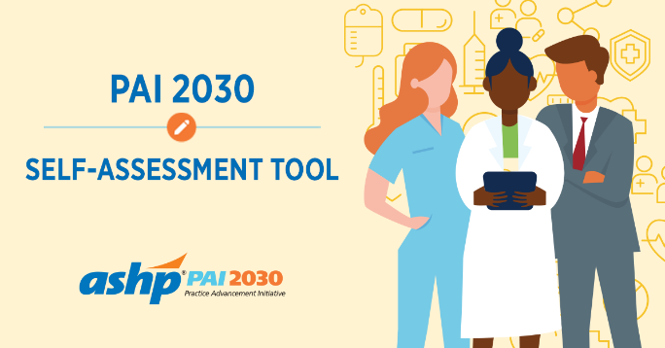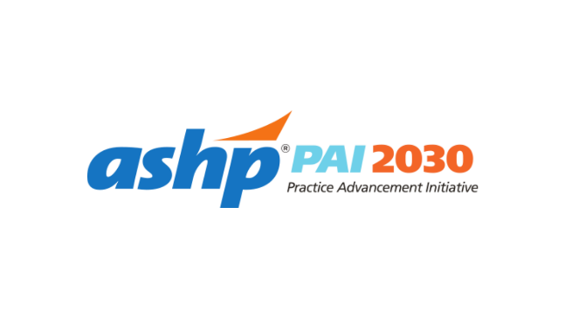

Sample Email Blurbs:
Self-Assessment Completion Request #1
Dear member [tailor to audience, e.g., State Hospital Pharmacy Directors],
Our state society has decided to take an active leadership role in the adoption of the ASHP Practice Advancement Initiative (PAI) 2030. We have created a state PAI 2030 leadership team and we are committing resources toward the advancement of the PAI 2030 project here in our state. We need your help!
ASHP’s PAI 2030 was created to advance pharmacy practice in the nation’s hospitals and health systems. A key PAI 2030 resource is the web-based PAI 2030 Self-Assessment Tool and a corresponding action plan. The tool is designed to identify gaps in both institutional and ambulatory care practice settings across the country when compared to the PAI 2030 recommendations.
We are asking that you complete the self-assessment for your practice site from the perspective of your “organization” and as an “official” assessment
We are striving for 100% of the hospitals in our state to complete the assessment. It will take approximately 45 minutes to complete the self-assessment and corresponding action plan. Please complete the PAI 2030 Self-Assessment Tool by <date> so preliminary data for our state can be compiled and ready for presentation by <when>.
We encourage you to engage your staff and learners in completing the assessment to ensure the response accurately reflects your site’s current practice. It is important to have every hospital and health-system site complete the survey so we have an accurate statewide baseline. This will enable us to tailor programs and services to best serve you.
Learn how pharmacy professionals at hospitals and health-systems across the country successfully implemented PAI 2030’s recommendations to advance patient care.

Sincerely,
State Society President

Self-Assessment Completion Request #2
Dear member [tailor to audience, e.g., State Hospital Pharmacy Directors],
Last month we sent you an email asking you to complete ASHP’s PAI 2030 Self-Assessment Tool. Our state society has decided to take an active role in promoting PAI 2030. We think it has the potential to be a powerful tool for advancement of pharmacy practice in health systems across the country.
The first and most important step in PAI 2030 is for every site to complete the self-assessment. The self-assessment will provide you with an action plan that will also help inform state priorities as part of the strategic planning process for practice advancement. The survey and corresponding action plan will take about 45 minutes to complete.
Many practice sites have already completed the survey tool. Our goal is to achieve a 100% completion rate statewide. Share your organization’s success story to inspire others and show how you have expanded pharmacy roles.
By <Insert Deadline> please take the self-assessment, complete the action plan, and let us know how we can help you succeed! After all, that’s why our state society exists…to help serve you!
Sincerely,
State Society President

Other healthcare personnel/learners:
Example message #1
Dear member [tailor to audience],
As a state affiliate of ASHP, we advocate for pharmacists and the pharmacy profession every day. ASHP’s Practice Advancement Initiative (PAI) 2030 provides pharmacy teams with guidance for advancing healthcare, patient outcomes, and pharmacy practice through 59 recommendations. ASHP has created a gap analysis resource called the PAI 2030 Self-Assessment Tool. Utilize this tool to identify areas in your practice where recommendations from PAI 2030 could have the biggest impact. The action plan derived from the self-assessment can be used to identify needed areas of improvement based on the recommendations. The assessment may be completed from the perspective of a single practitioner or as an organization. Use the action plan to aid your strategic planning and provide direction on focused efforts to adopt and implement PAI 2030 recommendations.
Sincerely,

Example message #2
Dear member [tailor to audience],
As you go through the ASHP PAI 2030 recommendations, utilize the health-system pharmacy leaders in your institution to determine which of the recommendations have already been implemented into your practice. After an initial assessment, identify recommendations that have been partially achieved or have not yet been implemented. Utilized the PAI 2030 Self-Assessment Tool to develop an action plan that will help prioritize which recommendations you wish to focus on first.
Sincerely,

Sample Affiliate Newsletter Article:
Newsletter: [Target – information that provides a very general overview of WHAT is PAI 2030 for members, Directors of Pharmacy, etc.]
ASHP’s Practice Advancement Initiative (PAI) began in 2010 to drive pharmacy practice change at a local level. The PAI was originally based on the results of two consensus-building conferences: one focused on acute care and another on ambulatory care. Building on this foundation, PAI 2030 includes 59 streamlined and updated recommendations to ensure the pharmacy profession meets the demands of future practice and patient-care delivery models.

Launched in 2020, the goal of ASHP’s PAI 2030 is to significantly advance the health and well-being of people by supporting patient-centered care delivery models that optimize the most effective use of pharmacists as direct patient care providers.

The original PAI recommendations remain an essential foundation of PAI 2030. The revised set of concepts are aspirational rather than prescriptive so practitioners can customize implementation plans for their institutional setting and revise as conditions evolve.

The guidance offered by the 59 PAI 2030 recommendations, which take into account environment trends that are likely to affect the pharmacy enterprise, will help pharmacists, health systems, and pharmacy leaders in their ongoing pursuit of optimal, safe, and effective use of medications.

State Affiliates play a major role in PAI 2030. Many states have utilized both the foundational PAI and PAI 2030 recommendations and the PAI 2030 Self-Assessment Tool as a jumping-off point for discussion about practice advancement opportunities in their state. Since its inception in 2010, ASHP’s PAI has resulted in a partnership with ASHP state affiliates, health systems, and pharmacists to help drive pharmacy practice change at a local level.

ASHP has created a resource called the PAI 2030 Self-Assessment Tool. Utilize this survey to identify areas in your practice where recommendations from PAI 2030 could have the biggest impact. The action plan derived from the self-assessment can be used to identify needed areas of improvement based on the recommendations. The assessment may be completed from the perspective of a single practitioner or as an organization. Use the action plan to aid your strategic planning and provide direction on focused efforts to adopt and implement PAI 2030 recommendations in your practice.

Sample Affiliate Newsletter and/or Press Release:

<Society Name> Creates PAI 2030 State Leadership Team

The <Society Name> has joined the nationwide campaign to advance pharmacy practice in hospitals and health systems. This campaign centers on the ASHP Practice Advancement Initiative (PAI) 2030.

The state campaign will begin with a concentrated effort to have every hospital in the state complete the PAI 2030 Self-Assessment Tool. This 45-minute assessment, applicable to both institutional and ambulatory care pharmacy practice settings, is designed to help determine how well a practice setting aligns with the PAI 2030 recommendations. Upon completion of the tool, pharmacy leaders are able to identify where the recommendations may have the largest impact on their setting, and will create a customized list of priorities for implementing change. Resources and articles related to each actionable item are also provided.

“This project is sizable for our state organization, but it has the potential to create a return of even greater proportion for pharmacy practice in our state,” said <Society Name> President <first name> <last name>. “Completing the PAI 2030 Self-Assessment is an initial step. We need every <hospital/ practice setting> to commit one hour to get it done. This will enable us to generate important data that can be used to plan programs for health-system pharmacists in our state. In addition, completion of the self-assessment provides departments of pharmacy with a blueprint for strategic planning to advance practice and patient care. This project has the potential to drive the focus and activity of our state society for the next three years. We are really excited about the potential.”

<Society Name> also plans to tailor its educational programming around the PAI 2030 project. Sessions for managers, clinicians, and pharmacy technicians will be offered. Watch for future announcements about these educational offerings.

The following <Society Name> members have been appointed to the PAI 2030 State Leadership Team

First Last Title Hospital or System
First Last Title Hospital or System
First Last Title Hospital or System

