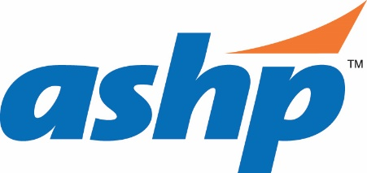

Instructions for Submitting Evidence of Residents’ Completion of CAGO Requirements
Please provide the Evidence/Deliverables from the residents’ portfolios for the Objectives listed for your program type (see individual program information):
- Evidence for 1 resident from the last full residency year and evidence of Deliverables completed by the date the pre-survey packet is due for 1 current resident. If your program is in Candidate status, please submit the Deliverables completed by the date the pre-survey packet is due for 1 resident.

There are 2 options for submitting Evidence associated with Required Objectives:
Option 1: Compile documents into a PDF file (may be best for past residents’ Deliverables)
Compile all Deliverables associated with the Required Objectives into a single PDF file using the following naming convention:
Resident X – Deliverables
Each Deliverable should be bookmarked using the associated Objective number and type of Deliverable:
Examples (from PGY2 Ambulatory Care Pharmacy):
1.1.5 - Note #1
1.1.5 - Note #2, etc.
2.2.6 - Major Project Presentation
2.2.6 - Major Project Manuscript
Completed files should be submitted with the Pre-survey Materials as a SEPARATE bookmarked PDF

Option 2: Upload documents to the individual Resident’s File tab in PharmAcademic™ (NOT Resident Portfolio)
Within the File tab for each Resident, please upload the documents requested in the Resident Deliverables Associated with Required Objectives list. Files should be named by the objective, then the deliverable type. If more than one example is included, number each example.
Examples (from PGY2 Ambulatory Care Pharmacy):
1.1.5 - Note #1
1.1.5 - Note #2, etc.
2.2.6 - Major Project Presentation
2.2.6 - Major Project Manuscript

