Pharmacy and Therapeutics (P&T) Committee
Medication Use Evaluation (MUE) Preparation Step-by-Step
Drug name: | generic/brand name®
AHFS Therapeutic class:
Manufacturer:
Date of review/approval by P&T: | dd/mm/yyyy
P&T conditions/criteria for use
P&T service restrictions (inpatient/outpatient/specific services/etc.)
Date MUE to be presented at P&T: | dd/mm/yyyy
MUE prepared by: | first and last name, PharmD, etc.
Preparer Email:
Preparer phone number:
- Background
- Brief background on disease/clinical issues

- Brief overview of agents used to treat

- Describe any guideline that includes use of agent / place in therapy per guidelines

- Drug under review (generic and brand name)

- Date of FDA approval and approved indication(s)

- Usual dosing

- Does drug have black box warning?

- Is drug a REMS drug?

- Specific insurance concerns (if none, state this):

- Product information
- How supplied:
- Usual dose per day/week/treatment cycle (use whichever is most relevant):
- Considerations for ordering. For example, is a special contract needed?
- Methods
- Review period (start and end dates)
- How patients were identified:
- Data elements captured during chart review (check all that apply):
  - Diagnosis
  - Service
  - Location of administration (inpatient vs infusion center vs office)
  - Dose / Administration issues
  - Relevant side effects (especially side effects related to Black Box warning, serious side effects. No need to include non-serious side effects unless important to the clinical service)
  - parameters suggested by service/pharmacist on service
  - issues with administration? (e.g. infusion time)
  - Safety issues?
  - Order set concerns/issues (is order set being followed or are changes being made during prescribing?)
  - Other outcomes (please specify)

- Describe any other sources used for clinical data review:

- Results
- Total number of patients
- Total number of doses
- Dosing – describe as flat or weight-based dosing as appropriate for the product
  - Min, max, mean, SD, median of doses/dosage per patient (if relevant)
- Present results in table format with % of patients or doses that met criteria
- Results reviewed with member of relevant clinical service

 | Criteria | Results (n and % that met criteria)
Criteria | Criterion 1 Diagnosis | n (___%)
 | Criterion 2 Ordering service
 | Criterion 3 Location of administration
 | Etc – list each criterion individually

Circumstances where criteria were not met
- Exceptions/Outliers
- Comments on exceptions/outliers
- How discrepancies/exceptions are defined/evaluated (be as explicit as possible)
Data collection limitations
Describe any limitations faced and any solutions proposed or put into place.
- Cost
Please round all costs to nearest dollar amount. You can use the table below (or something similar) to report findings. Please assure the following information is included:
- Cost per unit (tablet, vial, etc) (based on purchasing cost)
  - outpatient (340B)
  - inpatient (GPO/WAC)
- Cost per usual dose and/or usual treatment course (relevant timeframe)
  - outpatient (340B)
  - inpatient (GPO/WAC)
- Observed cost per year based on utilization
  - outpatient
  - inpatient
- Any additional cost due to adverse events, additional medications/ treatment/ device needed
  - pre-medications, testing needing prior to treatment (EKG, etc)
  - unanticipated hospitalization, ED visit, etc?
  - extended time in infusion center?
  - meds/intervention needed to manage adverse reaction?
- Did cost change during the review period?
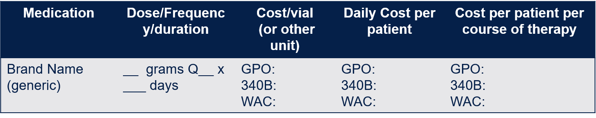

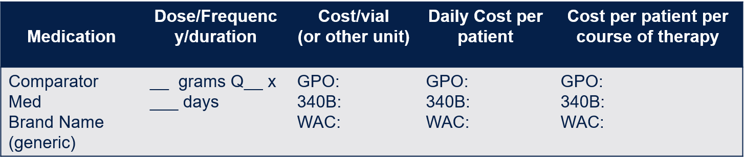
Forecasted vs. Actual Utilization and cost
- Please round to nearest dollar. You may consider the table below, or something like it to summarize the following:
- Forecasted vs actual utilization
- Forecasted vs actual cost and reimbursement
- Use, Cost of alternative treatments
- If a shift in product use was anticipated, how much shift has been observed?

- Potential Alternatives (if none, state there are none)
- Any new alternative(s)/ therapeutic interchange(s) that became approved/ available
- Is the alternative available on formulary? Are providers using the alternative(s)?
- Could the alternative(s) be used instead?
- What is the cost of the alternative(s)?
 | Estimated cost per patient per course of therapy | Estimated  annual cost (n=___) | Actual cost per course of therapy | Actual  annual cost (n=___)
Medication | GPO:  340B:  WAC: | GPO:  340B:  WAC: | GPO:  340B:  WAC: | GPO:  340B:  WAC:
Comparator Medication | GPO:  340B:  WAC: | GPO:  340B:  WAC: | GPO:  340B:  WAC: | GPO:  340B:  WAC:

- Summary
In a few sentences, summarize main points: drug, disease, purpose of MUE, and key findings.

- Recommendation(s)
- Recommended status on formulary
  - Maintain on formulary, restriction changes, etc
- Recommended changes to prescribing/dispensing workflow
- Plans for re-assessment or follow-up MUE, if appropriate
  - Outcome plan to carry out in follow up

References
Please list all references using AMA

