How to Combine and Bookmark PDF Files for Submission

Prior to combining all required documents into a single PDF file, all files should first be saved as Adobe PDF files. The program application, graduation certificate, and resident(s)’ signed offer letter should be scanned into PDF format.

For instructions on how to combine and bookmark files, select the appropriate link below based upon your current version of Adobe® Acrobat®.

Combine Files

Adobe Acrobat XI Tutorial
Adobe Acrobat DC Tutorial

Thumbnails and Bookmarks – scroll to ‘About Bookmarks’

When several PDF files are combined into a single document, automatic bookmarks are created. Please review these auto-generated bookmarks to ensure they mirror the document names listed in Document Checklist – if they do not match, PLEASE REVISE THE BOOKMARK names to match the document names in Document Checklist.

Examples of the correct use of bookmarks:
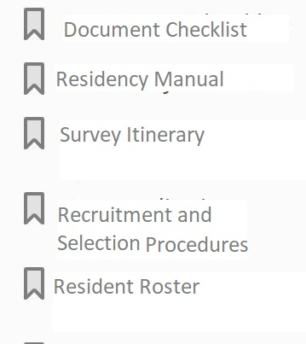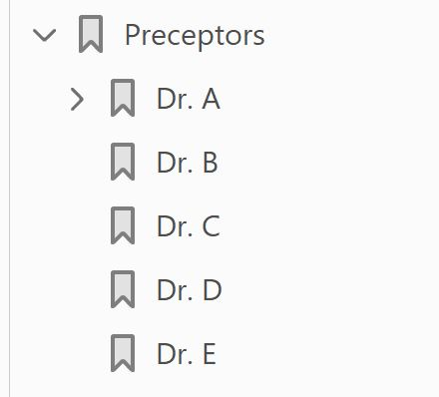

Please note – if a required document is included in your residency manual, you can bookmark the specific section/text. Instructions for this process are included in the Thumbnails and Bookmarks link. Alternately, you may include relevant page numbers on the Document Checklist instead of using the Bookmark function.

Specific Instructions for Bookmarks of Preceptor APRs, Multi-program sites, and Multi-site programs:
- For the Preceptors’ APR Forms, please create individual subfolders for each preceptor’s APR organized alphabetically by preceptor last name.
  - NOTE: If using PharmAcademic™ for APR submission, ALL APRs must be documented in PharmAcademic™ (note this on the DOCUMENT CHECKLIST); if some but not all are housed in PharmAcademic™, APRS MUST be submitted as a separate, combined PDF file
  - For multi-program sites, ALL site preceptor APRs should be combined into a single PDF file and submitted as part of the COMMON PACKET. (see Step 5.b, Multi-program Process in the OVERVIEW AND INSTRUCTIONS-PREPARING FOR YOUR SURVEY VISIT- APR and Preceptor Roster instructions)
- For multi-site programs†, create subfolders labeled by site name for documents that differ between sites.
e.g., Services grids, others as applicable

†Multiple-site residency: a residency site structure in which multiple organizations or practice sites are involved in the residency program. Examples include programs in which: residents spend greater than 25% of the program away from the sponsoring organization/main site at another single site; or there are multiple residents in a program and they are home-based in separate sites. Please see ASHP Regulations on Accreditation of Pharmacy Residencies

